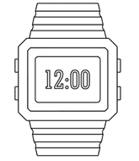

**PO3_DGW_Digital watch**

**(BUZZER)**

Table 1 Status Table

|  |  |  |  |  |
| --- | --- | --- | --- | --- |
| **Document Name** | **Author** | **Version** | **Date** | **Status** |
| Buzzer_CDD | Ahmed Qandeel | 1.0 | 4/3/2020 | Draft |

**DOCUMENT HISTORY**

Table Document History

|  |  |  |  |  |
| --- | --- | --- | --- | --- |
| **Version** | **Description of Change** | **Author** | **Date** | **Document Status** |
| 1 | Initial creation of Buzzer_CDD Document | Ahmed Qandeel | 4/3/2020 | Draft |

Table 3 Reference Table

|  |  |  |
| --- | --- | --- |
| Reference Input Documents | Version | Status |
| SRS | 1.7 | Proposed |
| GDD | 1.1 | Proposed |

Table of Contents

**1.Buzzer software context diagram** 3

2.Component ʹs application programming interfaces (APIs) 4

List of Tables

Table 1 Status Table 2

Table 2 Document History 2

Table 3 Reference Table 2

# **1.Switch software context diagram**

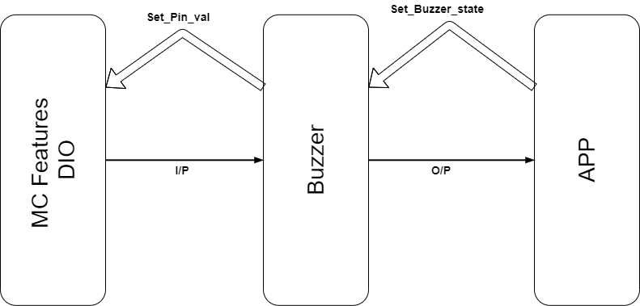

Figure . Buzzer context diagram.

# **2.Component ʹs application programming interfaces (APIs)**

|  |  |  |  |  |  |  |  |  |
| --- | --- | --- | --- | --- | --- | --- | --- | --- |
| **Req_ID** | | | Req_PO3_DGW_Buzzer_CDD_01_V01. | | | | | |
| **Covers** | | | Req_PO3_DGW_GDD_09_V01.0 | | | | | |
| **Author** | Ahmed Qandeel | | **Date** | | 4/3/2020 | | | |
| **API_Name** | | Buzzer_voidSetState | **Scope** | | | public | | |
| **Description** | | | It sets buzzer state according to its config file that it congiures its port and pin. | | | | | |
| **Inputs** | | | **Type** | **Name** | | | **Description** | **Range** |
| u8 | State | | | Buzzer state to set its pin to this state  High -> 1  Low -> 0 | 0 to 255 |
| **Outputs** | | | void | _____ | | | _____ | _____ |
| **Algorithm** | | |  | | | | | |